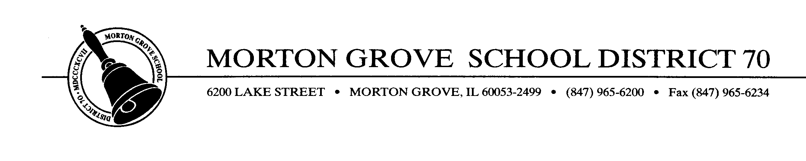
January 10, 2012

To Whom It May Concern:

It is with great pleasure that I recommend Dr. Joe Porto and his consulting firm to facilitate a Strategic Planning process for your organization. Last October we selected Joe and couldn’t have been more pleased with the final product as well as the process, in general.

From the outset, Joe was upfront and informative about the ideal size of the strategic planning committee, the different stakeholders that should be on the committee, and even the set-up for the room for the process. He described a four-session process that would culminate in a newly created mission statement, a set of beliefs or core values, and a three-year goal setting plan that identified topical areas each with a progression of outcomes for each of the three years. At first I had my doubts regarding exactly how much of this could be accomplished in that period of time, but now having been through the process I can say that Joe’s timeline and style of facilitation enabled our committee to accomplish all that we had set out to do, and in a high quality manner.

Regarding Joe’s style of facilitation, he demonstrates a very professional demeanor in a very personal way. One can see that he is very passionate about what he does and how he does it, but also challenges—in a nice way—all participants to not only think about what their organization currently does but how they would like to see their organization operate in the future. Joe did a nice job of “personalizing” the experience as he complimented various stakeholders for expressing thoughts and ideas that only helped the entire process run smoothly.

District 70 couldn’t have been more pleased with the outcome, the process, and the facilitator—Dr. Joe Porto—for an experience that drew stakeholders together to develop a quality product for our district. I would highly encourage anyone considering embarking on this process to contact Dr. Porto to see how best he can facilitate it for your organization/district.

Respectfully submitted,
Gary T. Zabilka
Gary T. Zabilka, Ed.D.
Superintendent

